FOR IMMEDIATE RELEASE
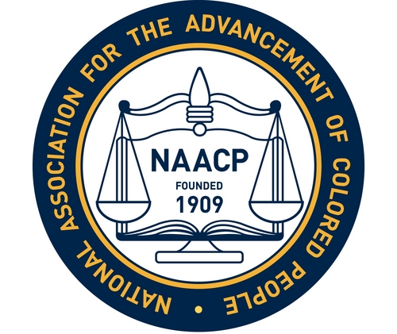
Media Contact:
Garry Holland
317.523.4363
education@indynaacp.org

NAACP Calls for Legislative Action to Reduce Lead Poisoning

INDIANAPOLIS, January 28, 2020 — The Greater Indianapolis NAACP Branch #3053 today called on the Indiana General Assembly to act immediately to prevent lead poisoning by moving forward legislation filed this year to increase screening for lead hazards in schools or lead levels in young children.

In partnership with the IU McKinney School of Law and the IU Office of Community Engagement, the NAACP is holding a public forum tonight about children’s exposure to lead and how Indiana could reduce childhood lead poisoning. A legislative forum Wednesday night will include a panel discussion with experts on childhood lead poisoning and public health policy from Michigan, Rhode Island, New York and Washington, D.C. Panelists will discuss proven strategies for reducing the dangers posed to children by lead in water, soil and homes.

- Tonight, Jan. 28: Community Forum: Addressing Risks of Lead Poisoning in Young Children; Featuring Neuropsychologist Vicki Sudhalter; 6:30 pm; The Bradley Building, First Baptist Church N. Indianapolis; 877 Udell Street.
- Wednesday Night, Jan. 29: Legislative Forum: Addressing Risks of Lead Poisoning in Young Children; 6:00 - 8:00 pm; IU McKinney School of Law, 530 West New York Street, Indianapolis

Indianapolis Star columnist Suzette Hackney reported on Sunday that schoolchildren in Marion County have been exposed to dangerous toxins like lead in school drinking water, but parents were not alerted of the potential exposure.

“The best way to identify children with lead poisoning is to follow federal guidelines and screen young children during their annual checkups,” said Greater Indianapolis NAACP Branch President Chrystal Ratcliffe. “Indiana has a poor record of conducting lead screenings for Medicaid-covered children during doctor visits. Parents and children deserve better from their doctors and from our state legislators.”

The Indiana General Assembly needs to act to ensure that school environments are tested for lead and other toxins, parents are notified and children are protected,” said Garry Holland, education chair for the Greater Indianapolis NAACP. “Our children are our most precious resource. To delay another year is an injustice to hundreds of children across Indiana.”

According to the U.S. Centers for Disease Control and Prevention, there is no known safe level of lead in young children, and millions of children are still exposed to lead in their homes.

"Preventing children from being exposed to lead has to be the priority,” said Dr. Janet Phoenix, a research professor at George Washington University’s Milken Institute School of Public Health. “The damage to their learning potential is permanent, so we can't wait. We need protective policies now."

According to the CDC, “Lead exposure can affect nearly every system in the body and is associated with numerous behavioral and learning problems (e.g. reduced IQ, attention-deficit/hyperactivity disorder, juvenile delinquency, and criminal behavior). Research indicates that even low levels of lead in a child’s blood can affect IQ, the ability to pay attention, and academic achievement.”

"Lead is a toxin. It is a poison. It destroys brain cells,” said Vicki Sudhalter, a Ph.D. neuropsychologist from Staten Island, NY, who will speak at tonight’s public forum. “You do not want your child's brain cells to be destroyed. No amount is OK for your child. This is irreversible. As the child grows into adulthood, they will indeed suffer cognitive disabilities.”

Federal law requires all children eligible for Medicaid to be screened for lead poisoning at 12 and 24 months. According to the state’s 2017 Childhood Lead Surveillance Report, while 94% of all Medicaid-eligible children received the measles-mumps-rubella vaccine, only 11% of those children were given the required blood lead test.

Four bills are pending in the Indiana General Assembly to reduce children’s lead exposures, but two have not yet received a hearing. The deadline for bills to be heard in committee is Thursday, January 30.

Sen. Lonnie Randolph and Sen. Rick Niemeyer have sponsored SB 214, which would require testing of the drinking water in every school building in Lake County at least once in each period of two calendar years to determine whether the drinking water exceeds the lead action level for drinking water established by the U.S. Environmental Protection Agency. A similar bill, HB 1265, is sponsored by Rep. Carolyn Jackson. Both bills have passed out of committee and are awaiting action on the Senate and House floors.

Sen. Jean Breaux has filed Senate Bill 286, which would set a more protective definition of lead poisoning in state law and require that all schools ensure that children are tested for elevated lead levels; and SB 285, which would require the State Department of Health to take all necessary steps to increase the number of Medicaid-covered children who are screened for lead poisoning. Neither bill is expected to be heard this year.

The Greater Indianapolis NAACP earlier this year pushed to create a Lead Testing Initiative to offer free testing to students in kindergarten and first grade at the Mayor’s Charter Schools, Indianapolis Public Schools and the Metropolitan School District of Pike Township.

# # #

